
AMERICAN INTERNATIONAL UNIVERSITY-BANGLADESH
Faculty of Science and Technology
Department of Computer Science
CSC 3215: Web Technologies

Semester: Summer 2025-26 | Group No: |  | Section: U

Group Members:
SL. | Student ID | Name | Role | Signature
1 | 23-51870-2 | AHSAN HABIB SHAWON | Group Leader
2 | 23-53460-3 | DOLON SAHA | Member
3 | 23-54908-3 | Surma Akter | Member
4 | 23-52227-2 | MD AJIZUL ISLAM IFTI | Member
Project Title
MEDICINE-SHOP-MANAGMENT-SYSTEM
Short Description
The Medicine Shop Management System is designed to manage medicines, stock, customers, and sales. It will help reduce manual work and make shop management faster and easier.
Introduction
The Medicine Shop Management System is a computerized system for managing the daily activities of a medicine shop. It will help manage medicine details, prices, stock, sales, and expiry dates efficiently.
Background Study
Traditional medicine shops often use paper-based records, which can cause errors and take more time. A computerized management system can store records safely, reduce errors, and make medicine and sales information easier to manage.
ER Diagram
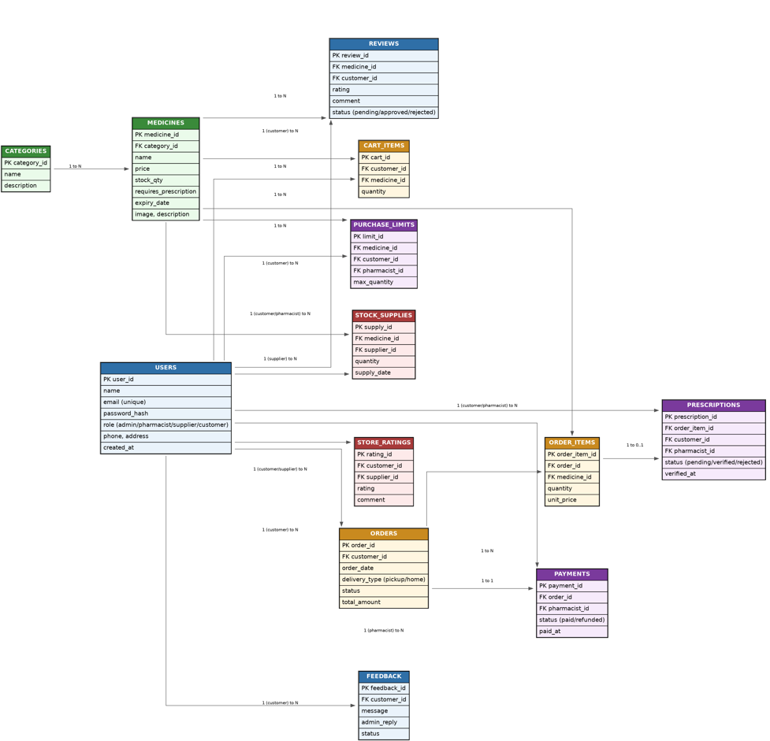
Fig: ER DIAGRAM OF MEDICINE SHOP MANAGEMENT SYSTEM
.
Use Case Diagram
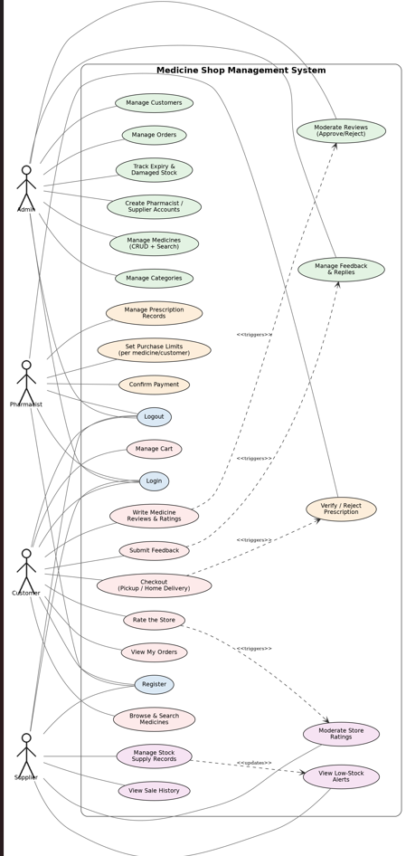
Fig: USE CASE DIAGRAM OF MEDICINE SHOP MANAGEMENT SYSTEM

UI (Figma/Sketch)
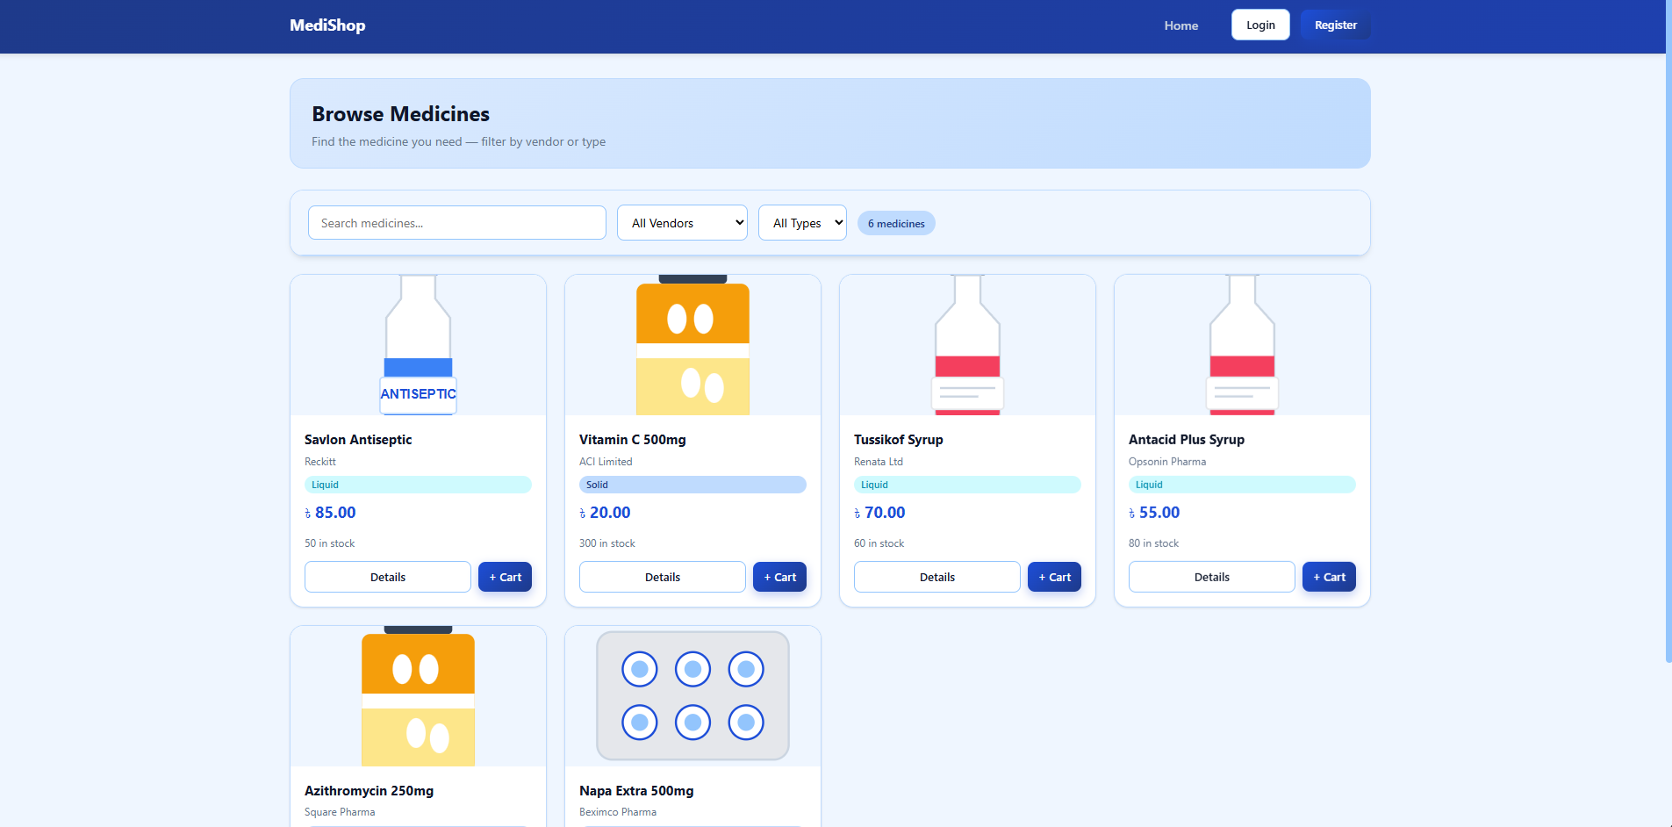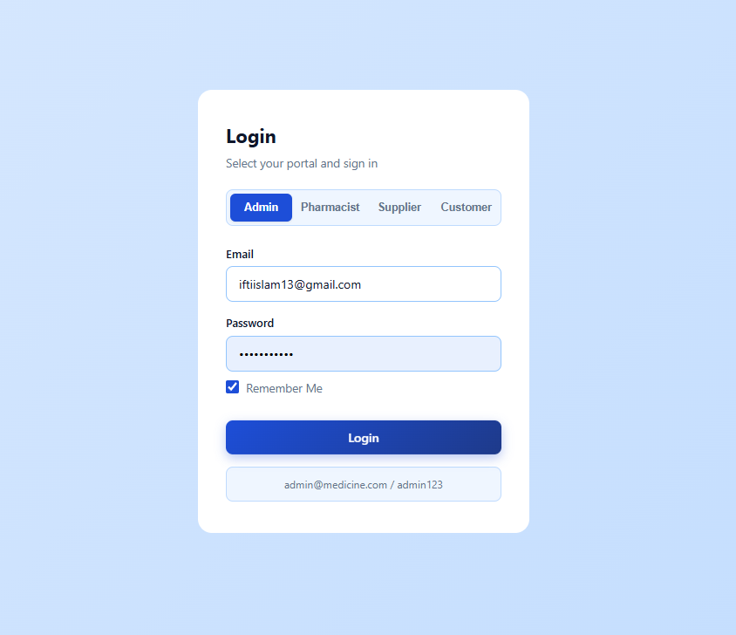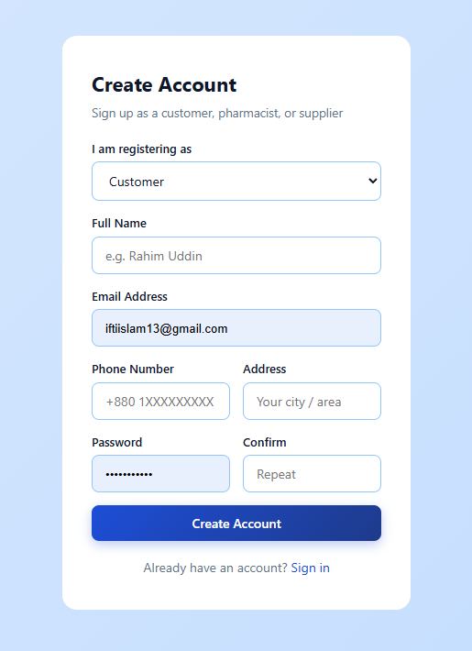
Fig1 : HOME PAGE fig:2 : LOG IN fig3: REGISTER

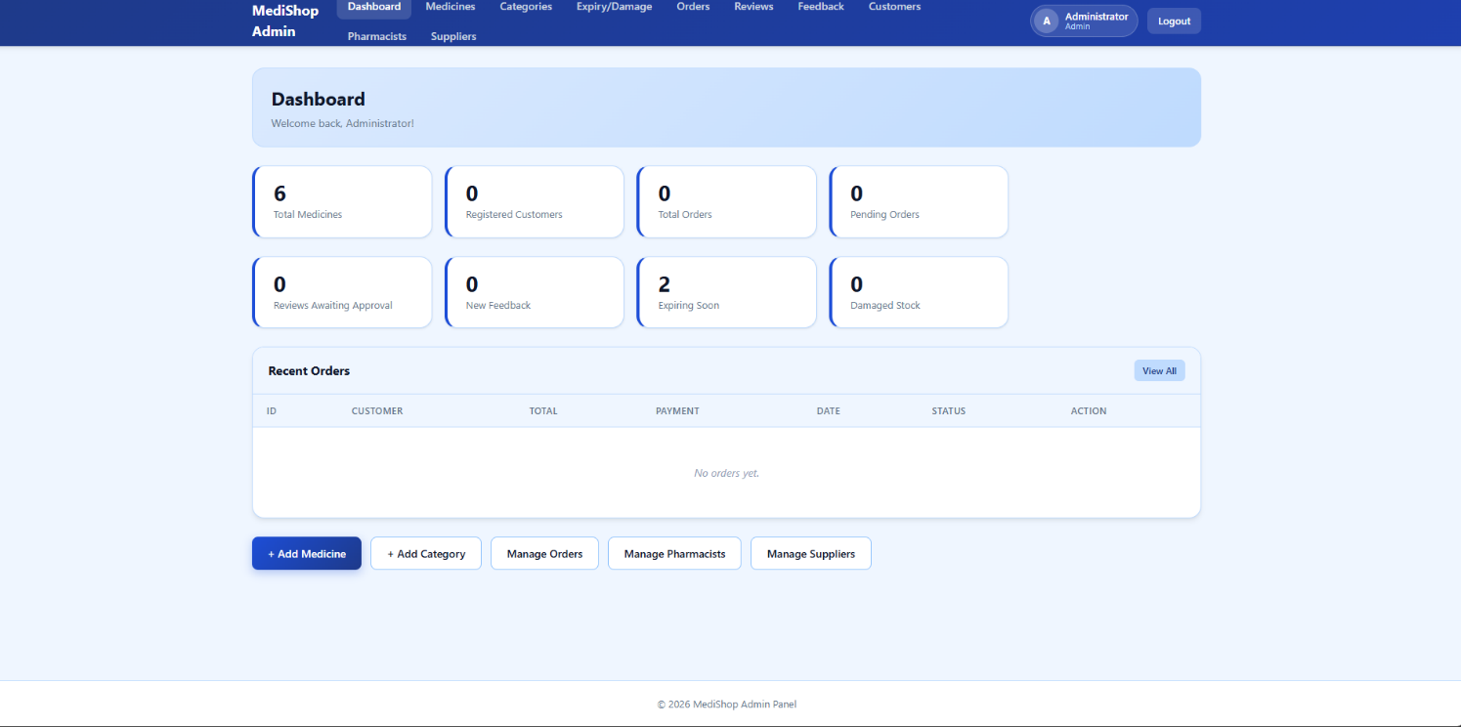
Fig4: admin dashboard

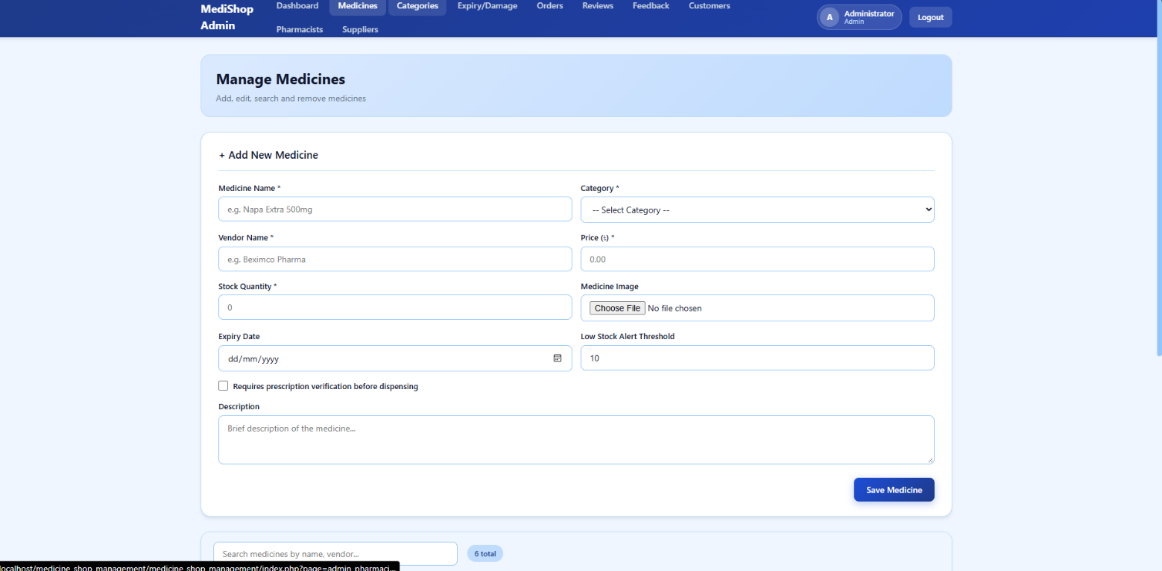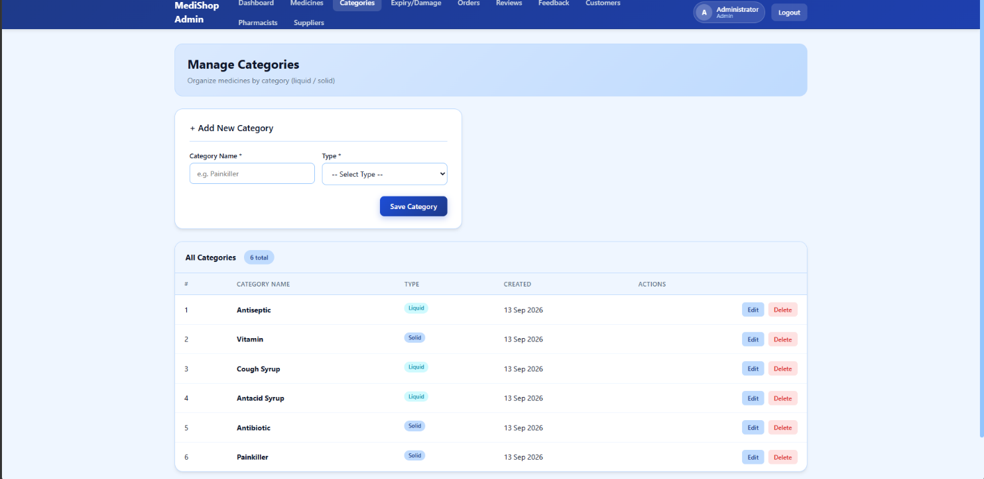
Fig5: manage medicine Fig6: categories

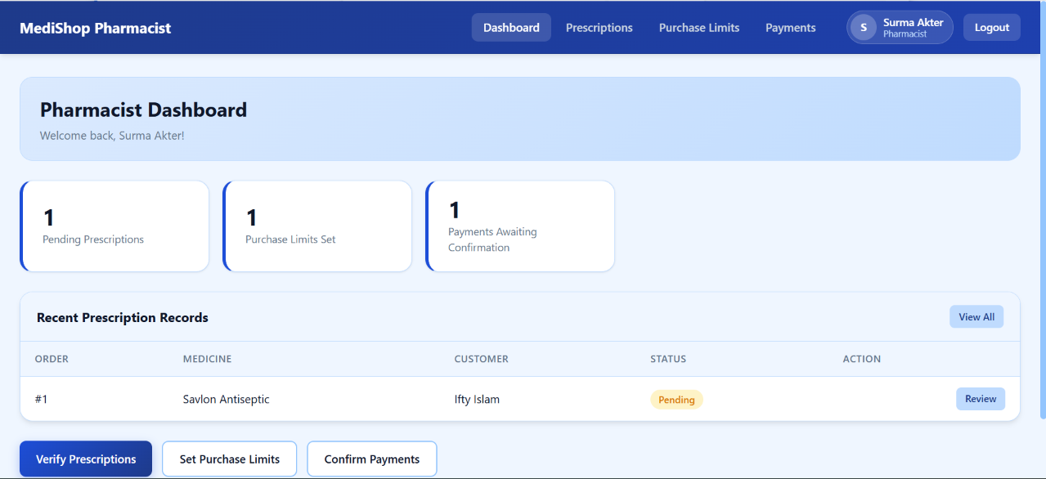
Fig7: PHARMACIST DASHBOARD
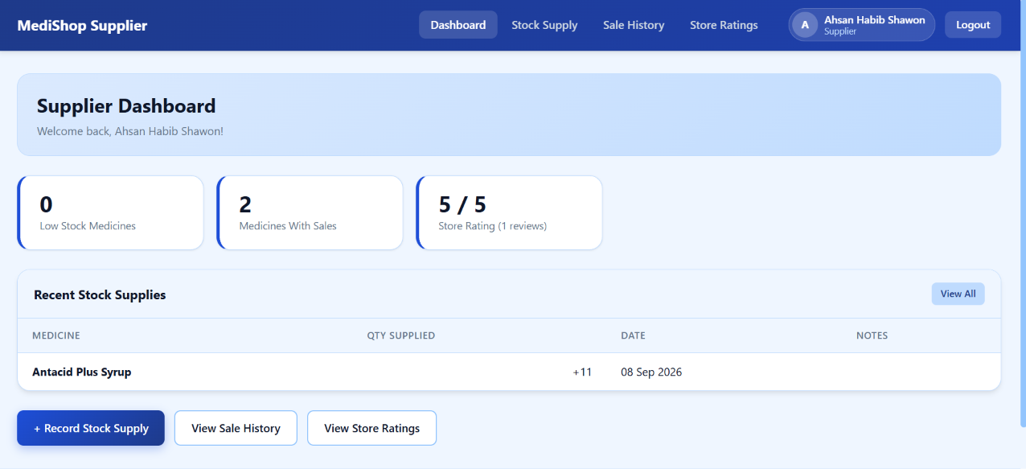
Fig8: SUPPLIER DASHBOARD

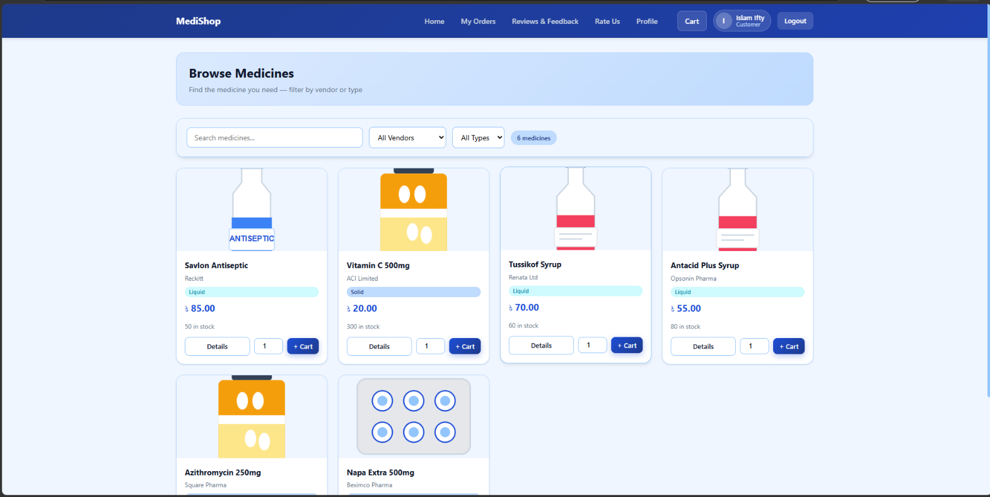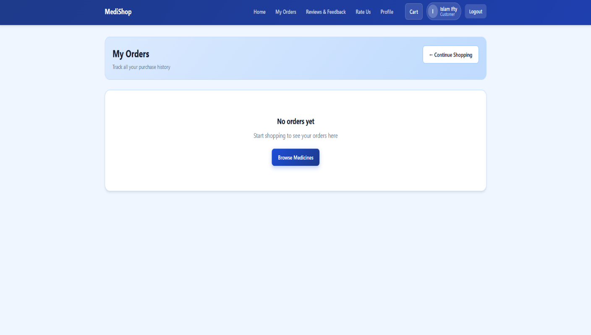
Fig9: CUSTOMER DASHBOARD Fig10: CUSTOMER ODERS

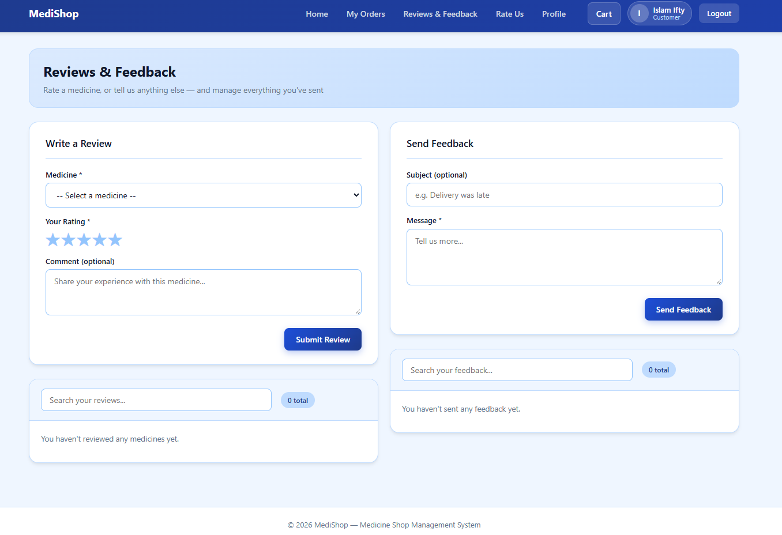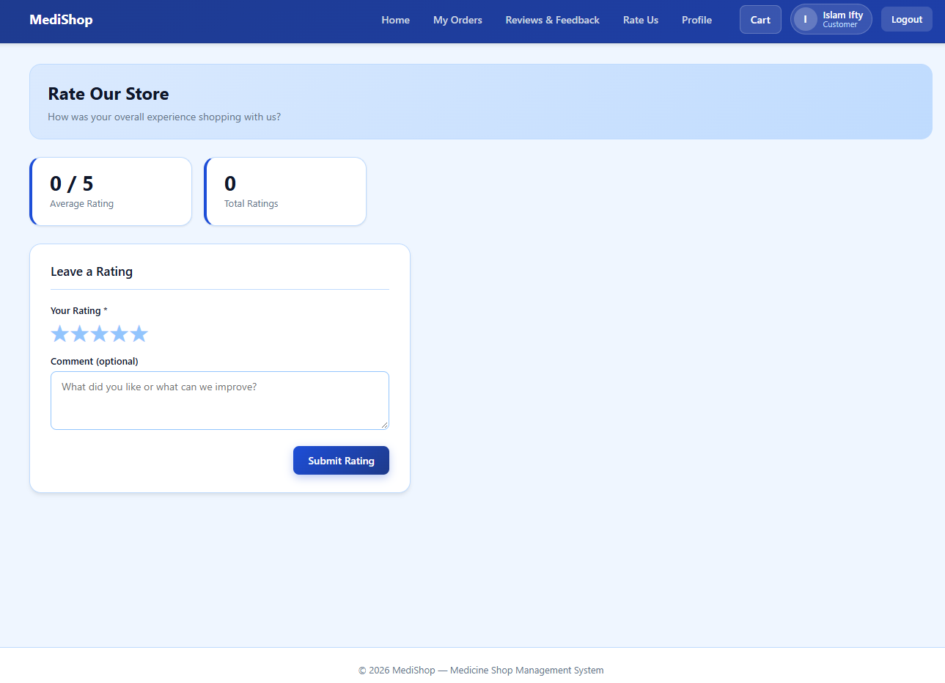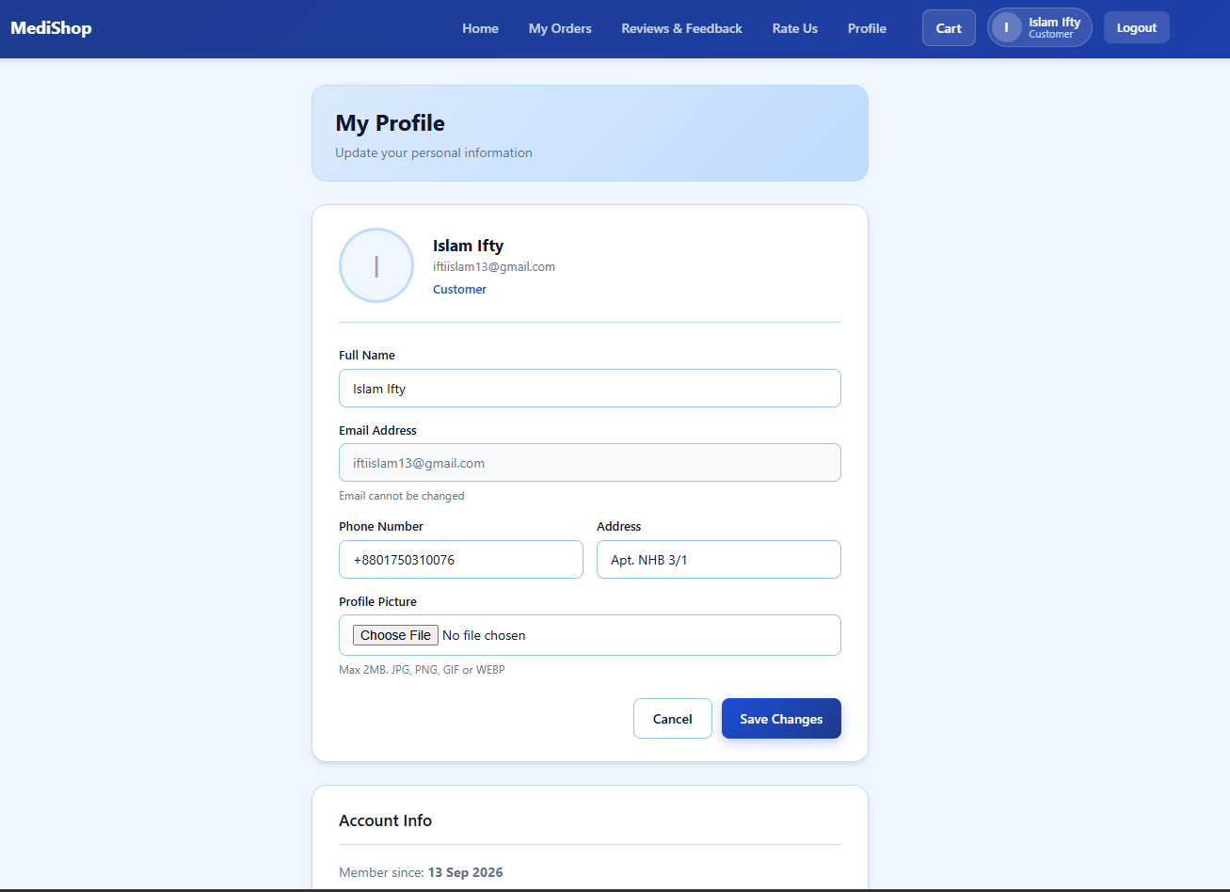
Fig11: CUSTOMER REVIEW & FEEDBACK Fig12: CUSTOMER RATING Fig13: CUSTOMER PROFILE

Types of Users: 1. Admin 2. Pharmacist 3. Supplier 4. Customer
Common Features (Available to All Users)
- Authentication
- Login to the system
- Logout from the system
- User registration
- Account Management
- Change or reset password
- Manage profile information (view, edit, delete)
- Dashboard
- Access a personalized dashboard after login
Specific Features by User Type
- Features of Admin
- Review moderation (Approve/Reject reviews)
- Expiry and damaged-stock tracking
- Feedback inbox with replies
- Features of Pharmacist
- Prescription verification
- Purchase limit per medicine and customer
- Payment confirmation
- Features of Supplier
- Low-stock alerts
- Sale history by medicine
- Store rating moderation
- Features of Customer
- Pickup or home delivery at checkout
- Medicine reviews and ratings
- Feedback with replies and store rating

